Latch Hooking Instructions

[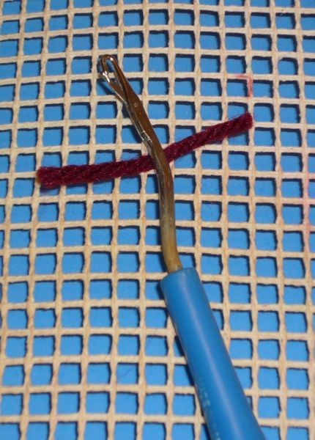](http://www.wikihow.com/images/f/f2/A4a_302.JPG)

Loop or fold the yarn around the base of the hook, beneath the swinging latch

[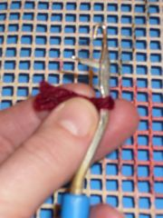](http://www.wikihow.com/Image:A4b_637.JPG)

Fold or loop the yarn around the shaft.

[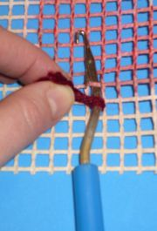](http://www.wikihow.com/Image:A4c_732.JPG)

[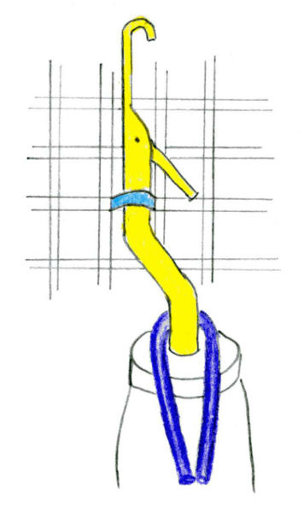](http://www.wikihow.com/images/7/7b/Latch_hook004.jpg)

Stick the hook under the canvas bar in the bottom of the first square, so that the latch passes under the canvas bar and back up to the top side again

[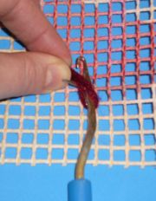](http://www.wikihow.com/Image:A4d_865.JPG)

Take the ends of the loop and put them over the canvas bar, through the latch and under the actual hook.

[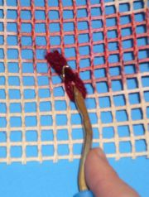](http://www.wikihow.com/Image:A4e_597.JPG)

Pull on the hook to close the latch over the yarn ends.

[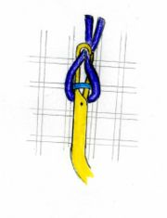](http://www.wikihow.com/Image:Latch_hook005.jpg)

[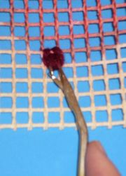](http://www.wikihow.com/Image:A4f_511.JPG)

[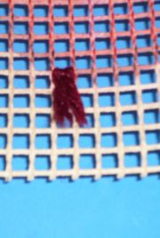](http://www.wikihow.com/Image:A4g_856.JPG)

Close the latch and pull firmly on the hook handle so that you're pulling the yarn ends back under the canvas bar and through the original loop. The yarn should be neatly attached to the canvas by a slip-type knot (sometimes known as a larkshead knot).

**[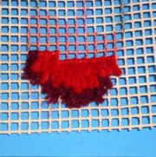](http://www.wikihow.com/Image:A5_204.JPG)**

Proceed row by row up the pattern until you're done.