Chapter 5
Life in British North America
Pages 76-98

Important Terms
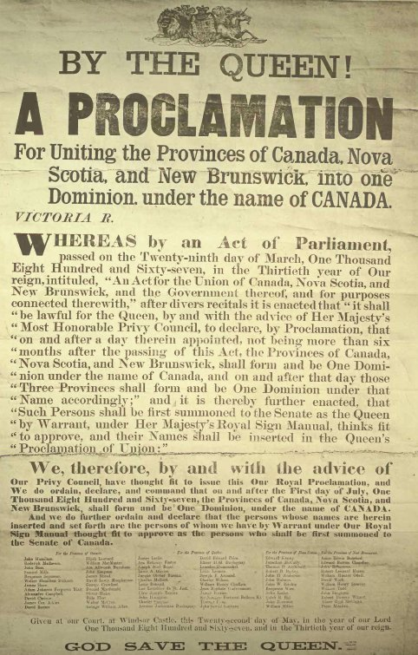
Census
Majority
Minority
Rural
Urban
Immigrants
Elite
Prejudiced
Discrimination
Habitants
Grand Derangement/ Expulsion
Colony
Loyalists
Acadians
Epidemic
Racist
Title
Publicly funded school

Main Concepts
Students must be able to explain the following:
- Who were the five groups of people that made up the BNA, and what were their lives like in the 1800’s
- The basic geography of the BNA
  - What were the crown colonies and HBC lands
  - Where did most people live
  - What was the largest city/population
- The basic economy of BNA in each colony
- How the Irish, French, First Nations, and Black Colonists were all victims of discrimination/disempowerment

British North America (BNA)-mid 1800s

BNA took up approximately the same area of land that Canada does today but it was a very different kind of place.

British North America in the mid 1800’s was shaped by two important events:
• Great Britain won all of Frances North American colonies in 1763
• The American Revolution of 1776, the British colonies south of New Brunswick rebelled against great Britain- they won and became the USA

Colony is a territory of the “home” country in another part of the world. All important decisions are made by the government at home.

For example: Newfoundland was a colony of Britain,

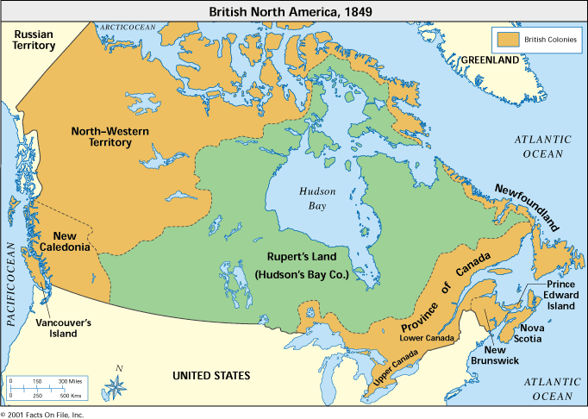
(you will need to be able to label these on a map)

The Province of Canada was made up of:
- Canada East – mostly people of French heritage
- Canada West – mostly people of British heritage

Within all the different colonies Europeans were the majority and First Nation and Inuit were the minority.

Majority- greater number of people

Minority- less number of people

North-Western Territory, Rupert’s Land, Vancouver’s Island and New Caledonia
- Hudson’s Bay Company- was a British fur trading company - Great Britain gave it control of these areas
- The company had fur trading posts in key locations all along the rivers
- This was important because Goods Transported by canoe

French shore
An area covered by a treaty, from 1783-1904. It gave fishers from France the right to live and fish along certain parts of NL.

Population of BNA

- 1851- population = 2 536 000 (concentrated in Eastern Colonies)
- Largest city (Canada East) = Montreal
- Largest city (Maritimes) = Saint John, NB
- In Colonies Europeans = majority (greater number of people)
- First Nations/ Inuit = minority (less number of people)
- In Hudson’s Bay company (HBC) lands population was small, majority = First Nations/Inuit
- Mid 1800’s population was 85% rural and 15% urban

Rural- living on farms or in other places outside towns and cities

Urban- living in cities or towns

Census- when the government counts the people and other information, like a persons’ type of work, where they live and their heritage. Beginning in 1851 the Newfoundland government started doing this every 10 years.

Economies of British North America

In the mid 1800’s BNA was controlled by European settlers. Economies were based on natural resources- fish, fur, timber and farming. Manufacturing was started but not a big industry. First Nations/Inuit struggled to survive in Atlantic region because of European settlement. Aboriginal peoples carried on their traditional economies and participated in the fur trade even when lands were under control of the Hudson Bay Company.

Newfoundland
- Economy based on cod selling to Europe
- Many small fishing communities along the coast
- 1/5 of the population lived in St. John’s
- In Labrador there were fur traders along the coast

New Brunswick
- Centre for ship building
- 100 ships per year
- People lived mostly in small farming and logging communities
- Saint John was the centre of trade with US and Great Britain

Nova Scotia
- Most people lived in the coast
- Most people worked as fishers, sailors, and shipbuilders
- Port of call for British Navy
- Centre of trade
- Some manufacturing was also starting up for a variety of wood, leather, and metal goods.

Prince Edward Island
- Shipbuilding was the strongest part of the economy
- Farming was also important
- Farmers paid rent to absentee landowners- land owners not living there

Hudson Bay Company Lands
- Fur trading
- Trading Post with First Nations and Inuit peoples

The Peoples of British North America

Immigrant – is a person who comes to live in a country that is not his or her original home

Prejudice – is the dislike or distrust of a person or group based on biased ideas or information

Discrimination – is the unfair treatment based on prejudice

In 1700 and 1800’s most immigrants were of British or Irish heritage. There were a small number of people of African heritage.

The Elite- is a small class of people that has more political, economic and social power than the majority. In BNA the elite was made up of families of British heritage (Scottish or English). Newfoundland, the British merchants who controlled the fishing industry also formed elite. In all the colonies, the elite had the largest businesses, and set the social standards for the communities. The elite were not interested in sharing their power with others.

Loyalists- were people from the US who had sided with Great Britain and had come to Canada after the American Revolution.

Newer Immigrants
Between 1815 and 1850 about 800 000 English, Scottish and Irish immigrants came to BNA because of hard economic times in their homelands- they hoped for life in BNA. English and Scottish worked hard and tried to stay healthy so they could get positions of power and wealth. Many of the English were prejudiced against the Irish because of problems between these groups in Great Britain and Ireland.

The British
- Had more political, economic and social power
- They were the families of people of British heritage
- In the colonies for several generations
- Also there were loyalists – people who came after the American revolution
- In Newfoundland these people were the merchants

The Irish
- They hoped for a better life here
- Irish were discriminated against from English business owners
- They could not get jobs
- Irish were Roman Catholic
- Couldn’t get jobs in English businesses

The French
- The French were divided into two main groups

Those in the East  - Only a small elite  - Most were farmers in rural areas  - In 1763 they were given special rights  - Allowed to keep their language, customs, and laws  - Most of Roman Catholic faith | Acadians  - Included people from PEI, NS, NB  - Descendants of the 1st settlers  - Strong communities based on fishing  - Acadia was the first permanent French settlement in North America  - The Grand Derangement of 1755 (Great Expulsion) 8000-10 000 Acadians were forced to leave their homes.  - Some were imprisoned  - The Acadians were not trusted by the British  - Were allowed to return in time  - Lived in great poverty
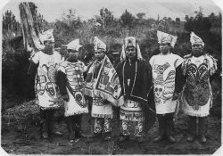

Aboriginal People
- British did not treat the people has a different nation
- British government controlled the people
- British had racist ideas and attitudes this resulted in discrimination in many situations
- In effect, the arrival of more immigrants led the government to take more land from the aboriginals
- Eventually they were left with small areas of poor quality land and faced starvation
- The population dropped from approx... 500 000 before contact to 102 000 by 1871, this was due to starvation and disease. They had little resistance to deadly European diseases.
- The Metis found their place working in the fur trade at the Red River Settlement that was run by the HBC.

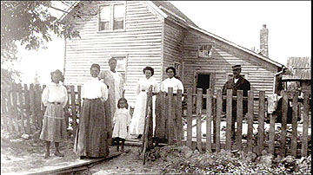 Black Colonists

- About 3000 Black Loyalists came to BNA after the American Revolution
- Their land was poor and they had a hard time getting official title – legal record of land
- Set up strong communities but had few opportunities and experienced discrimination
- Could only get the lowest paying work and the poorest land
- Slavery was legal until 1834
- There were many free black people

Daily life in British North America

Homes
- Variety of sizes and kinds of furniture
- Depend on what the person could afford
- Wealthy homes were large and elegant
- Farmers homes might be one room made from rough logs and dirt floors
- Aboriginal homes were traditional
- Light came from candles or from oil lamps
- Heat from fire places or wood stoves
- No indoor plumbing, used outhouses
- Water from wells, springs, or lake brought by hand
- The wealthiest homes might have a hand pump in the kitchen
- Hot water was heated over the fire

Transportation
- All transportation was difficult
- Rough roads in the colonies
- People traveled mostly by river because settlements were often by a river and the coastline
- Travel on land was by foot, horse, or oxen
- In winter people used sleds

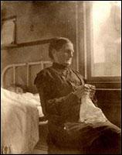
General Hospital patients, post-1880.
Few health-care services existed in Newfoundland and Labrador at the start of the 19th century.
Health Care
- Diseases and serious disabilities from accidents were much more common than today
- Many childhood diseases, such as measles, scarlet fever, and whooping cough could cause death
- Diseases could spread very quickly in an area- epidemic
- Health care provided mostly by family members.
- People used traditional medicines such as herbs or roots
- Aboriginal peoples understood these medicines and shared their knowledge
- Rural areas were unlikely to ever see a doctor
- Medical care was very simple because doctors could little to treat most illnesses.

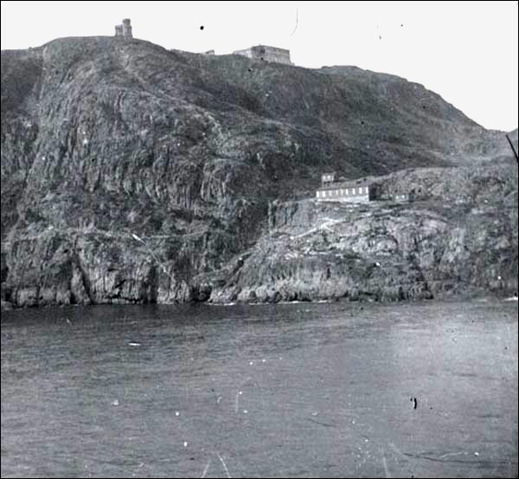
Cabot Tower and Isolation Hospital, n.d.
The Ross's Valley Hospital (pictured right), opened on Signal Hill in the 1890s to isolate fever, smallpox, and epidemic patients from the general public. Its remote location, however, made it difficult to reach and the facility rarely received patients. It was destroyed by fire in 1911 and never rebuilt.

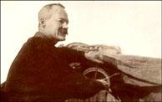
Wilfred Grenfell, ca. 1910
When British physician Wilfred Grenfell visited Labrador in 1892, he was shocked by the lack of medical attention residents of that area received. He began a fundraising campaign later that year which allowed him to establish a hospital at Battle Harbour in 1893 and another at Indian Harbour in 1894. As a result of Grenfell's work, many more hospitals and nursing stations opened in Labrador and northern Newfoundland.
Education
- Going to school was not considered to be important
- A lot of European settlers could read and write
- They were taught at home by family members
- Books were highly prized
- Reading was an important pastime
- In the earlier years
  - Schools were run by religious organizations
  - Parents helped in these schools
  - Proper behaviour and religious instruction was the most important
  - Children would go to different schools depending on their religion
  - Wealthiest families had private tutors in their homes
- Latter years
  - Publicly funded schools were set up- paid for by the government
  - Mostly white people\language depended on the majority in the community
- Church groups also ran schools for the First Nation communities
- The main goal of these schools was to teach the children about European culture and religion

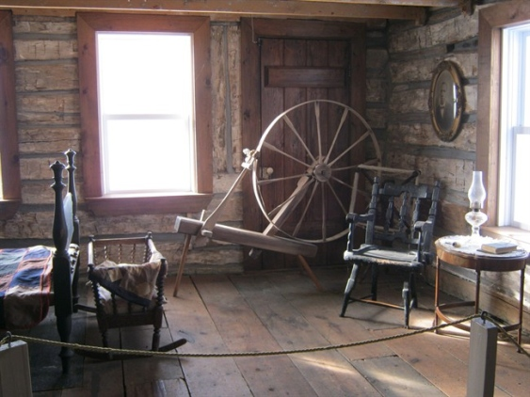 Pastimes
- People enjoyed playing or watching outdoor sports, doing crafts such needle work or carving, making music with friends, reading or storytelling, and playing games.
- Pastimes were part of traditions
- People in cities had more opportunities for activities including some special events like musical performances
- Rural communities made a party of getting together to get something done such as building a barn or making a quilt.

