Economic Security
In this chapter you will investigate the question, Why do People need economic security? What is your personal response to this? How important is economic security to you as you think about your future?
Important Terms: Students should know each of these terms
Please complete all of thr following terms
Economics:
_________________________________________________________________________________________________________________________________________________________________________________________________________

Employers:
_________________________________________________________________________________________________________________________________________________________________________________________________________

Capitalism:
_________________________________________________________________________________________________________________________________________________________________________________________________________

Socialism:
_________________________________________________________________________________________________________________________________________________________________________________________________________

Capital:
_________________________________________________________________________________________________________________________________________________________________________________________________________

Profit:
_________________________________________________________________________________________________________________________________________________________________________________________________________

Entrepreneur:
_________________________________________________________________________________________________________________________________________________________________________________________________________

Standard of Living: ______________________________________________________________________________________________________________________________________

Poverty _________________________________________________________________________________________________________________________________________________________________________________________________________

Quality of Life
_________________________________________________________________________________________________________________________________________________________________________________________________________

Poverty Cycle
_________________________________________________________________________________________________________________________________________________________________________________________________________

Personal Capital
_________________________________________________________________________________________________________________________________________________________________________________________________________

Down Payment
_________________________________________________________________________________________________________________________________________________________________________________________________________

Mortgage
_________________________________________________________________________________________________________________________________________________________________________________________________________

Bias
_________________________________________________________________________________________________________________________________________________________________________________________________________

Stereotyping
_________________________________________________________________________________________________________________________________________________________________________________________________________

Needs and Wants: (page 43)

Most economic systems we have read about so far this year are based on with a person’s ________________ that can be met by money.

Some needs and wants are things that money cannot buy.

Needs and Want Chart
Example | Want | Need | Can be Met By Money | Cannot be Met with Money
Food
Water
Education
Toys
Health
Friendship
House
Family

When people choose what work to do some people do not always choose the best paying job they also consider:
- _______________________
- _______________________

Workers and Employers (page 44)

The main idea of a ______________________ is that most of the goods and services people want are produced by private companies.

The main goal of companies is to make a ________

The Flow chart below shows that how money moves through the Canadian economy. The more people buy, the more goods and services are needed. This creates more jobs, which means that more people have more money to spend.

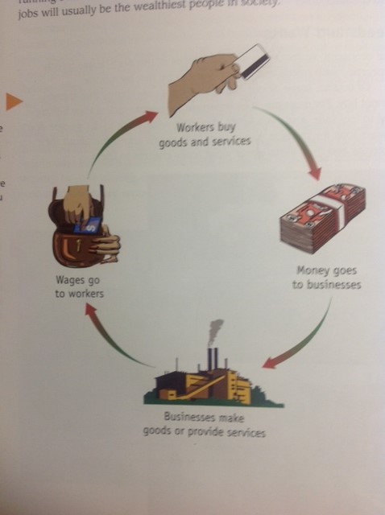
Distribution of Wealth

There are two main economic systems in the world ___________ and ___________.
Socialism
_____________________________________________________________________________________________________________________________________________________________________________________________________________________________________________________________________________________

Capitalism
________________________________________________________________________________________________________________________________________________________________________________________________________________________________________________________________________________________________________________________________________________________________________________

- Which economic system does Canada Have?
_____________________________________________________________
- Which economic system to you think is better, and give two reasons why.
________________________________________________________________________________________________________________________________________________________________________________________________________________________________________________________________
Businesses and Community Wealth (page46)
The term _____________ comes from the word _________.
Capital ________________________________________________________________________________________________________________________________
Profit ________________________________________________________________________________________________________________________________
There are many different types of businesses in Newfoundland:
- Some people work for themselves… takeout, farmers, fishermen
- Big companies own smaller businesses in many places in the province or the country

When new businesses start up, it helps to create _________.

How does a business help to create wealth in a community?

____________________________________________________________________________________________________________________________________________________________________________________________________________________________________________________________________________
Cause and Effect (page 49)

When you are considering cause and effect of a situation you must look for the connection between the two

Cause: ____________________________________

Effect: ____________________________________

Cause Effect
Mill Closes Workers become unemployed

It is important to realize that situations are often more complicated than one cause and one effect.

Complete

Cause Effect

- ________________________ School internet is no longer
- ________________________ available to students
- ________________________
- ________________________
- ________________________

You can look further to determine what will result from the effect.

In each situation there is a ___________ which is the actual change that created the causes.

What is poverty? (page 50)

In Canada many people have problems meeting their basic needs much less anything special they may want.

Standard of living ___________________________________________________________________

What are the two basic ways to determine if a person or family lives with poverty:

- ______________________________________________________________________________________________________________________________________________________________________________________________________________________________________________________________________________________________________________________________________________________________________________

- ______________________________________________________________________________________________________________________________________________________________________________________________________________________________________________________________________________________________________________________________________________________________________________

When expenses are higher than income, the result is poverty.

Many people find that their income just covers their basic needs.

As soon as your income is more than the cost of your basic needs, you have economic security.

Quality of Life: ______________________________________________________________________________________________________________________________________

What types of things would you include in a good quality of life?
____________________________________________________________________________________________________________________________________________________________________________________________________________________________________________________________________________

Why do We Have Poverty? (page 52)

Poverty Cycle: ______________________________________________________________________________________________________________________________________

Once you have reached the point where you don’t have enough income to meet your basic needs, it is hard to get what you need to improve your life.

Two examples of how the poverty cycle works:

1.
Poverty
People living with poverty often have problems because they can’t afford healthy food, regular dental care, and warm clothing.
If you are not healthy, it is hard to work. If you cannot work you cannot earn a living

Can’t Work Poor Health

2.
People living with poverty might not be able to afford the things they need in order to look for work.
If you can’t afford a car and can’t afford to take a bus, you might not be able to get to job interviews.
Poverty

Can’t get to job
Interviews

No Transportation

Building Personal Capital (page 54)
Personal capital: _________________________________________________________________________________________________________________________________________________________________________________________________________

Using money wisely (page 54)
Once you have more income than your cost of living, the extra income becomes part of your personal capital.

Owning a Home (page 55)
Down Payment: ____________________________________________________
Mortgage: ____________________________________________________________________________________________________________________________________________________________________________________________________________________________________________________________________________
When a family uses a mortgage to purchase a house, the family must make payment each month; this will increase the amount of the house that the family owns.
Once the mortgage is paid off the house then become capital because it can be mortgaged again or sold to get money.

Breaking the Poverty Cycle (page 55)
People break the poverty cycle all the time, although it may not be easy. One way to break the cycle is to get training or further your education to improve your job skills. It is also easier to break the poverty cycle when people work together to help each other.

