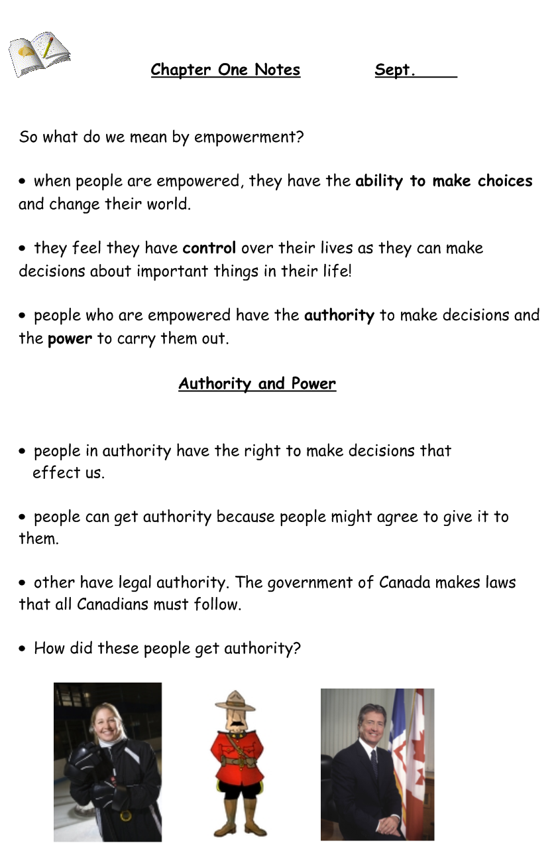
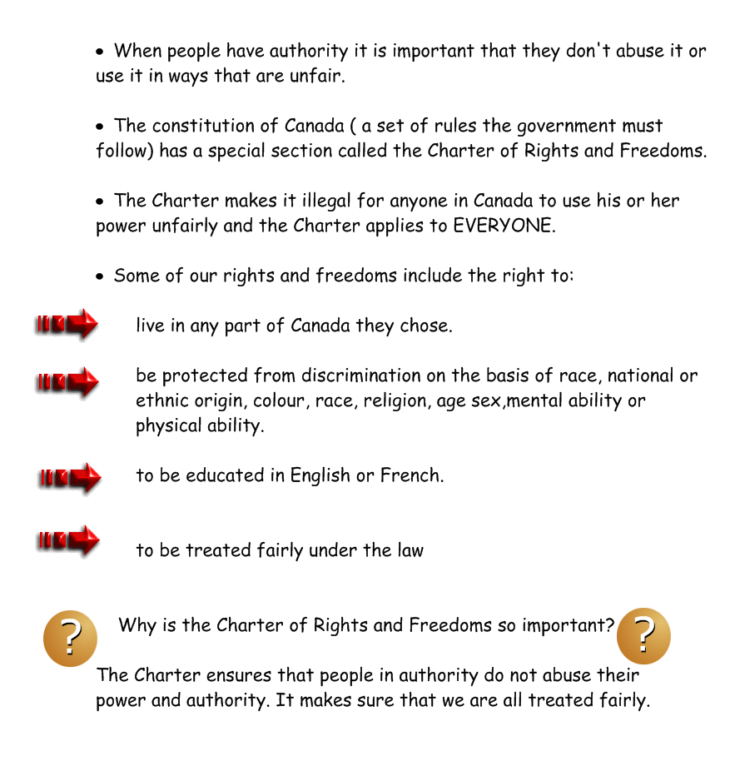

Age of majority : (age 18) the age at which the law considers you an adult. You are legally responsible for your actions.

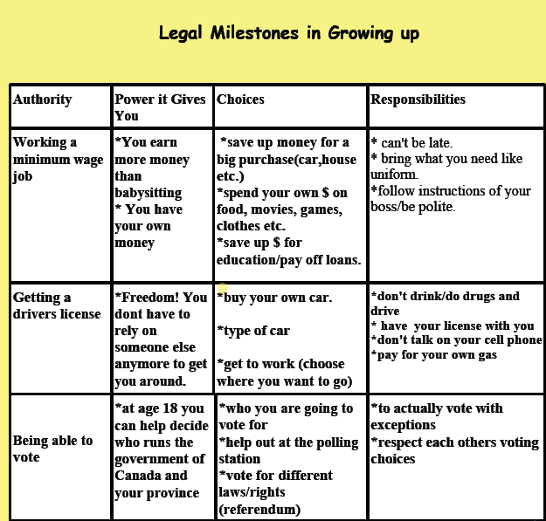

Personal Empowerment

Personal Empowerment: means having the ability to do something about your needs, wants opinions and beliefs. There are many ways how you right now at your age can have personal empowerment.

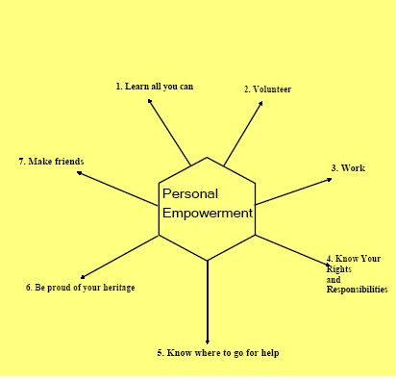

**Be able to explain each of these…how would you show each of these areas of personal empowerment in your life???

